Weekly Contribution
10/4 10/11
Envelopes $2,397 $1,997
Loose $ 118 $ 131
Candles $ 2 $ 5
Building $ 435 $ 335
CSMA $ 535
Masses $ 90
Food Pantry $ 755 $ 520
Attendance 89 87

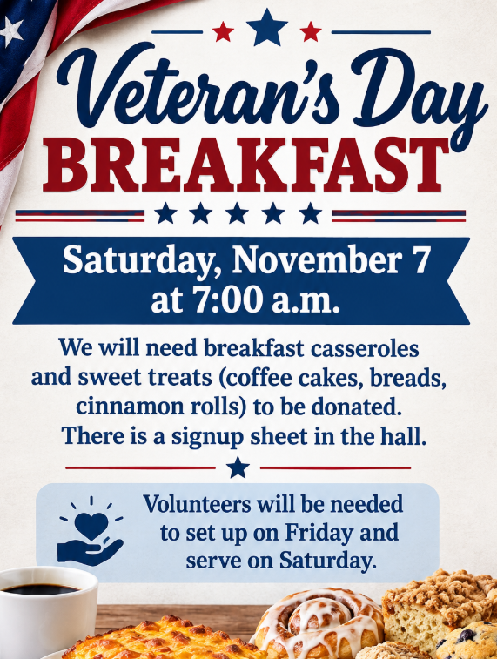
~ Mission Statement ~
We, of St. Edward Catholic Church, Fairfield Illinois, united as a family of God's people strive to live out the Gospel of our Lord Jesus Christ through a community spirit of love and service to one another. We endeavor to touch the lives of all with God's living presence and love.
We hope to achieve these through:
- Participating in the sacraments and providing for the spiritual needs of all; the young and the elderly, those with special needs and those who are no longer very active in the parish.
- Providing a welcoming environment to all including new members who might like to join our parish and those who visit to worship with us.
- Using our gifts and talents for the life and growth of our parish and for the greater glory of God.
- Providing a comprehensive system of support services that will assist the poor and the needy as far as our scope can reach.

St. Edward News

St. Edward News

Travel Opportunity
Pilgrimage to Poland, Prague and Medjugorie
11 day trip ~ April 19-29, 2027

It is through Journey of Faith Tours. For more information call Carolyn at 732-216-8073 go to www.journeyoffaithtours.com/ppm27.

Or you can talk to Linda Keck, as she is going on this pilgrimage.

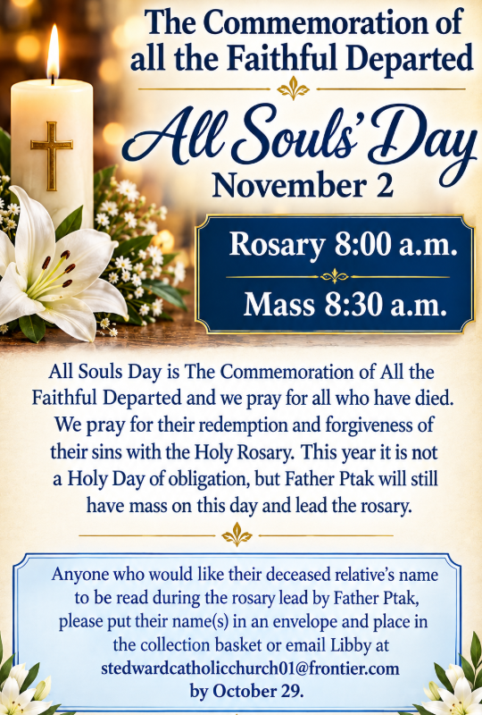
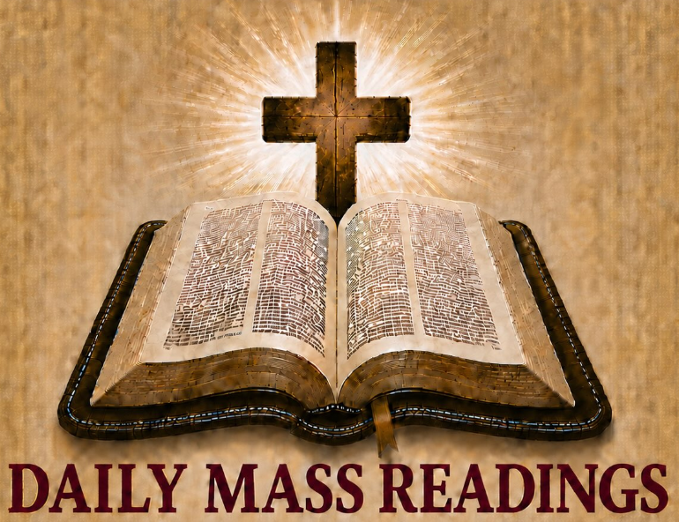

for October 18-24

- Sun – Is 45:1, 4-6 1 Th 1:1-5b
Mt 22:15-21
- Mon – Eph 2: 1-10 Lk 12: 13-21
- Tues – Eph 2: 12-22 Lk 12:35-38
- Wed – Eph 3: 2-12 Lk 12:39-48
- Thu – Eph 3:14-21 Lk 12: 49-53
- Fri – Eph 4: 1-6 Lk 12:54-59
- Sat – Eph 4: 7-16 Lk 13:1-9

Congratulations St. Edward
We have reached our CSMA
goal of $6,948.

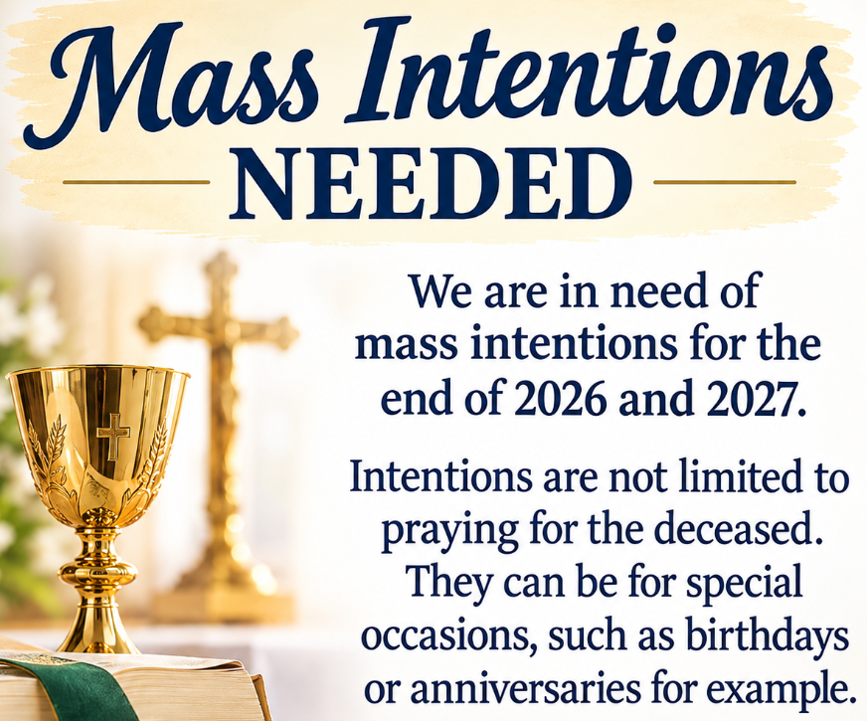
Compassion Pregnancy Walk-a-thon

Teresa Williams will be participating in the walk-a-thon. If you would like to help her raise money for the worthy cause, the signup sheet is on the table in the hall.

New Outdoor Electric Sign
Total Cost $24,448.66
Donations Collected $12,500.00
Needed $11,946.66
If you are interested in donating to the sign, you can place your donation in the collection. Please mark it as sign donation.
Kim Buchanan, Lanora Neavill,
Margaret & Jim Thompson,
Richard Rennier, Lee Bouldin, Father Ray, Marty Hawkins, Glory Alman,
H.G. French, Mike & Carol Oppenheimer,
Sue Milligan, Kate Krupp, Lidija Bilus, Gayla Templeman, Sharon Withrow,
Gary Snodgrass, Sandra Stence,
Paul Kalisz, Larry McDowell and
Mary Murphy

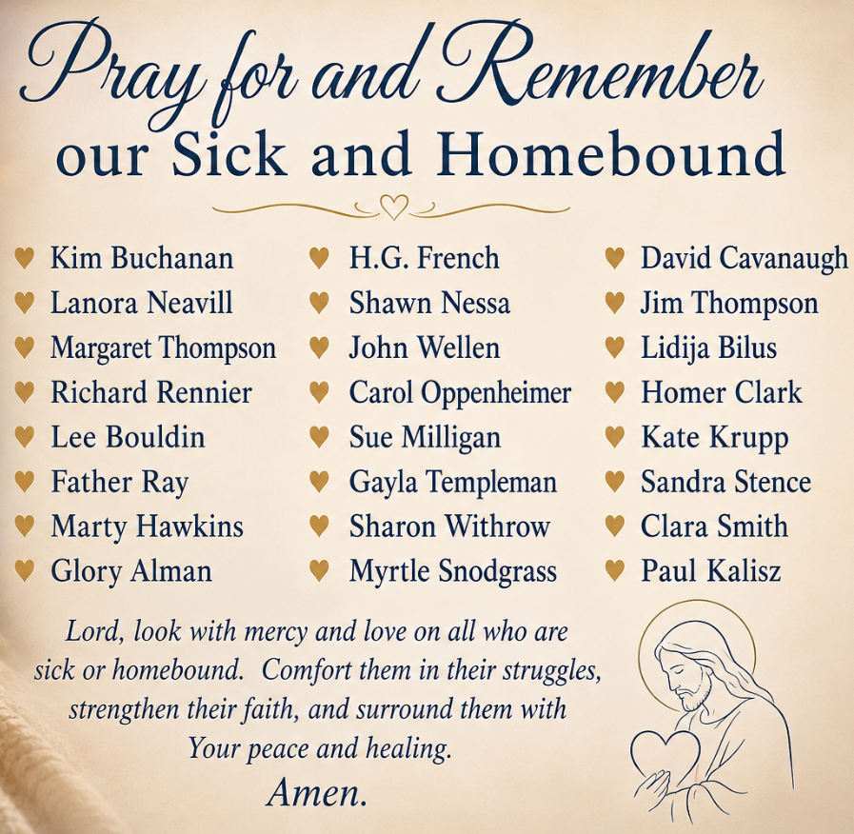

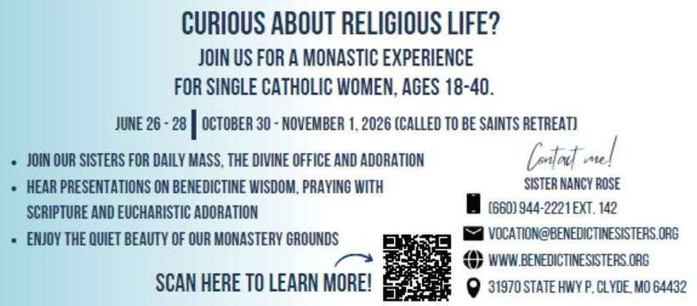
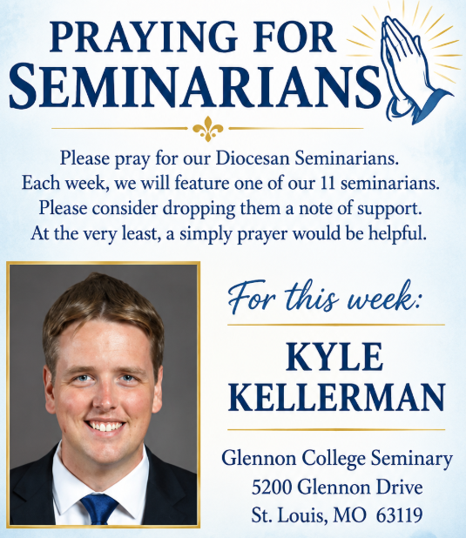

Our Parish Mission
We the parishioners of St. John the Baptist, brothers and sisters in Christ, accept as our mission: to know our faith and share it with others, to continue to grow spiritually with respect for the sacraments, to celebrate the liturgy and the Holy Eucharist as the center of our Christian life, to live by truth and love, to serve those in need, to teach by example, and thereby strengthen and inspire our Parish family in accordance with the Roman Catholic Church.

Shared in Common

St. John News



October
- 18: New Server Training after Mass
- 18: PSR & Bible Study 9:30 a.m.
- 18: One Strong Youth Feeding the Foxes followed with Youth Group
- 20: Ladies Quilting 8:00 a.m. - 1:00 p.m. City Hall/Market Street
- 20: OCIA Class 6:00 p.m.
- 22: AA/NA Meeting 7:00 p.m. City Hall/Market Street
- 23: No Weekday Mass
- 24: One Strong Youth Soup & Salad Supper 5:30 p.m. Masquerade Trivia 6:30 p.m.
- 25: New Server Training after Mass
- 25: PSR & Bible Study 9:30 a.m.
- 25: October 25 Trunk or Treat 4:00-6:00 p.m. around hall. If bad weather, will be in hall.
- 27: Ladies Quilting 8:00 a.m. - 1:00 p.m. City Hall/Market Street
- 28: East Vicariate Priest Gathering 11:00 a.m. - St. Mary Mt. Carmel
- 29: AA/NA Meeting 7:00 p.m. City Hall/Market Street
- 31: Daylight savings time ends November 1. Turn clocks back on hour before going to bed.
November
- 1: 9:30 - 10:15 PSR & Bible Study
- 1: Mass at St. Edward 8:30 a.m., due to PSR Saint Parade
- 1: Mass at St. John the Baptist 10:30 a.m. following with PSR Saint Parade in Hall
- 1: PSR Sunday - Rosary: Confirmation - Greeters: First Communion - Petitions: 5th-7th
- 1: No New Server Training after Mass
- 2: All Souls' Day Rosary 5:30 p.m. led by Fr. Ptak
- 2: All Souls' Day Mass 6:00 p.m. - Not Holy Day of Obligation - Following Mass at St. John
the Baptist Cemetery Visit to pray and place lit candles after Mass, weather permitting.
- 2: Holy Name Society Meeting 7:00 p.m. Refreshments
- 3: Ladies Quilting 8:00 a.m. - 1:00 p.m. City Hall/Market Street
- 5: AA/NA Meeting 7:00 p.m. City Hall/Market Street
- 6: Visit for Sacrament of Penance & Eucharist for sick and homebound. Contact
office for appointment.
- 7: Wedding of Grady Lueke & Hallie Woodrow without Mass 3:00 p.m.
- 7: Mass 5:00 p.m.
- 8: PSR & Bible Study 9:30 p.m.
- 8: St. Elizabeth's Pretzel Bake 4:00 p.m. Everyone Welcome from young to old!
- 10: Ladies Quilting 8:00 a.m. - 1:00 p.m. City Hall/Market Street
- 12: AA/NA Meeting 7:00 p.m. City Hall/Market Street
- 12-23: Dahlgren KC Coat Drive - Drop off boxes located front of church, Piopolis &
Dahlgren Hall, or office.
- 14: Happy Birthday Father Slawomir Ptak
- 14: Wedding Mass of Jacob Wuebbels and Kaylee Stewart 3:00 p.m.
- 14: No Mass due to Wuebbels & Stewart Wedding
- 15: PSR & Bible Study 9:30 p.m.
- 17: Ladies Quilting 8:00 a.m. - 1:00 p.m. City Hall/Market Street
- 19: KC #8745 Meeting at Dahlgren 7:00 p.m.
- 19: KC #7118 Meeting at Piopolis 7:00 p.m. - Pizza Night
- 19: AA/NA Meeting 7:00 p.m. City Hall/Market Street
- 20: St. Elizabeth's Altar Sodality cooking for Chamber of Commerce Dinner
- 21-22 & 28-29: Two Week Bulletin
- 22: 9:30 - 10:15 PSR & Bible Study
- 22: Mass at St. Edward 8:30 a.m., due to One Strong Harvest Fest
- 22: Mass at St. John the Baptist 10:30 a.m. Welcome new servers during Mass. Following
with One Strong Harvest Fest in hall till 2:00 p.m.
- 24: Ladies Quilting 8:00 a.m. - 1:00 p.m. City Hall/Market Street
- 25: East Vicariate Priest Gathering 11:00 a.m. - St. Mary Mt. Carmel
- 26-27: Office Closed
- 29: No PSR or Bible Study

For This Week

GRANT FENDER
Glennon College Seminary
5200 Glennon Drive
St. Louis, MO 63119

Saint John Vianney, pray for us.


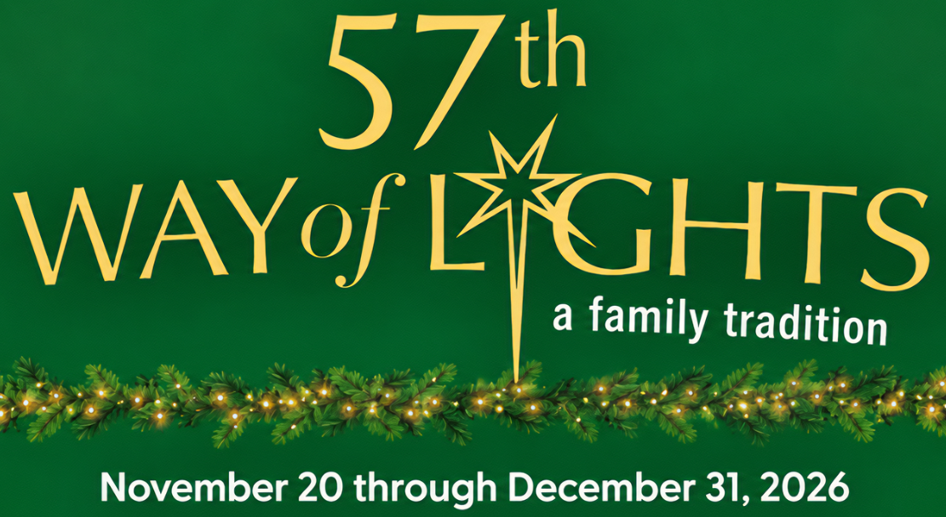
"I am the voice of one calling in the desert, Make straight the way of the Lord."
Jn 1:23
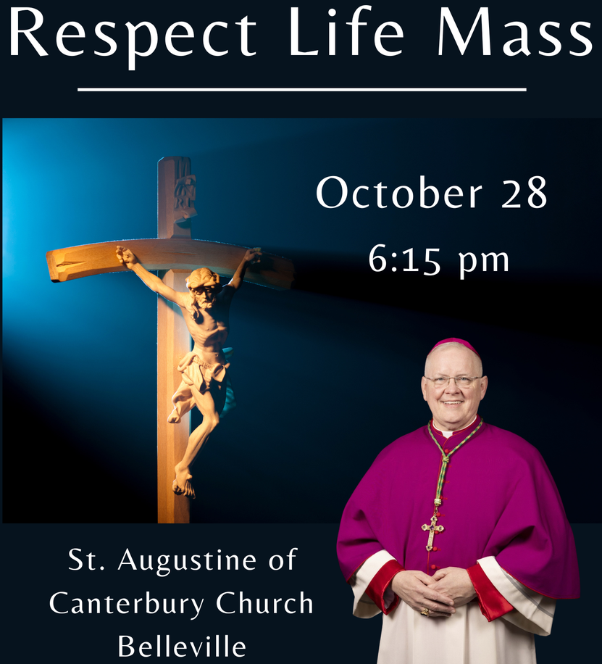
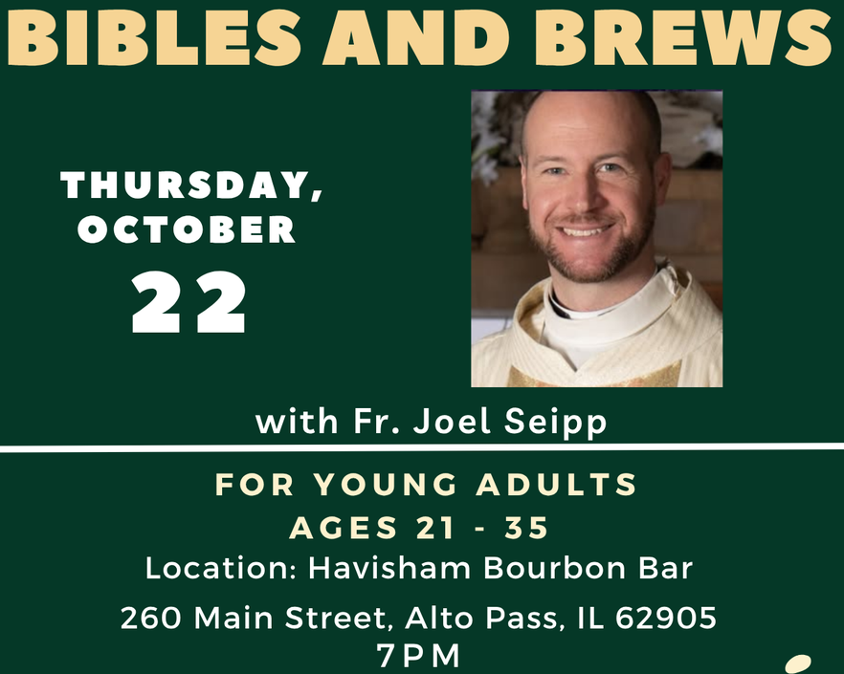
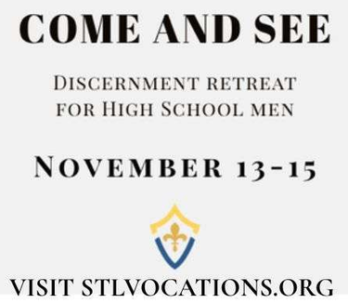
October Liturgical Calendar
- 18: Laity & World Mission Sunday
- 19: Sts. John de Brebeuf & Isaac Jogues,
Priests and Compassions, Martyrs
- 20: St. Paul of the Cross, Priest
- 22: St. John Paul II, Pope
- 23: St. John of Capistrano, Priest
- 24: St. Anthony Mary Claret, Bishop
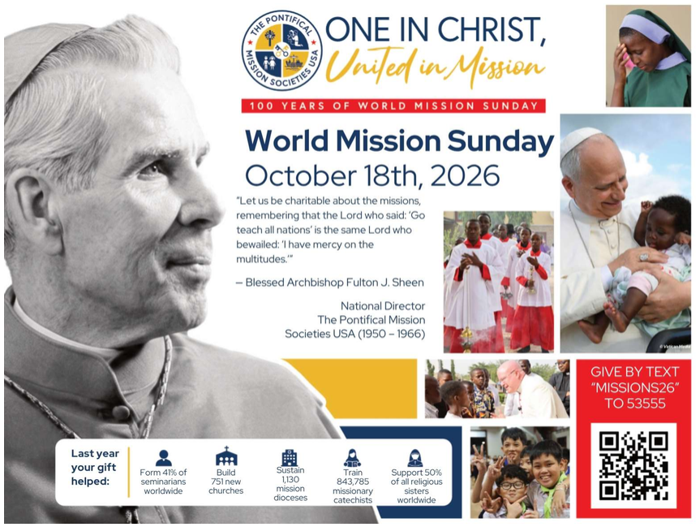
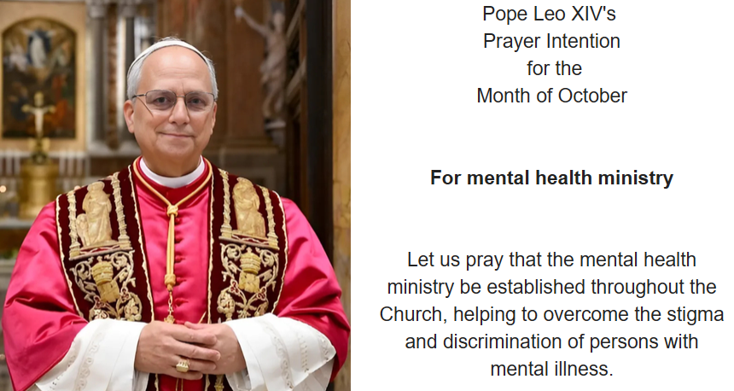
Mass Intentions for the Twenty-Ninth Week in Ordinary Time
Tues. Oct. 20 St. Edward 6:00 p.m. †Jerry Zurliene, †Fr. David Voelker, †Joseph Bednarczyk
Wed. Oct. 21 St. John 6:00 p.m. †Larry Hunt, †Fr. Leo Hayes, Private Intention
Thur. Oct. 22 St. Edward 8:00 a.m. All Parish Family
Fri. Oct. 23 St. John NO MASS
Mass Intentions for Thirtieth Sunday in Ordinary Time
Sat. Oct. 24 St. John 5:00 p.m. †Norman Rubenacker, †Clem Aydt, ††Beulah Vincent & Ova Thacker
Sun. Oct. 25 St. John 8:30 a.m. All Parish Family
Sun. Oct. 25 St. Edward 10:30 a.m. ††Tom & Alice Zurliene, †Pilar Henley, †Stanley Krzysko
Sacrament of Reconciliation before weekend masses.

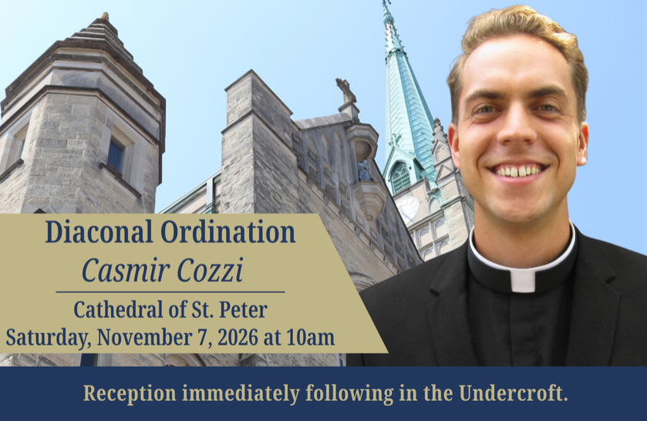
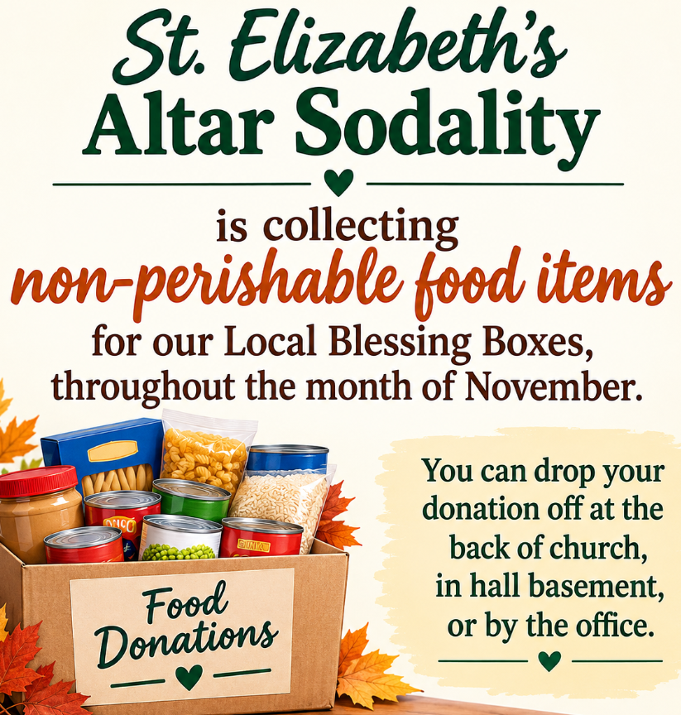
New Parish Hall Construction Update
The west entrance to church is closed, so construction of breezeway can begin, please use front or east entrance. Thank you all for your donations so far to the new building. Your financial support has been amazing! Because of your generosity, we haven’t had to take the loan from the Diocese yet. We will, but we’ve been able to delay it, thus saving interest! As we near the end of the year, don’t forget to fulfill your pledge contributions for 2026. And for those who didn’t pledge, you can still make any donation any time. Pledge cards are located at each door of church and can be placed in collection marked New Hall.
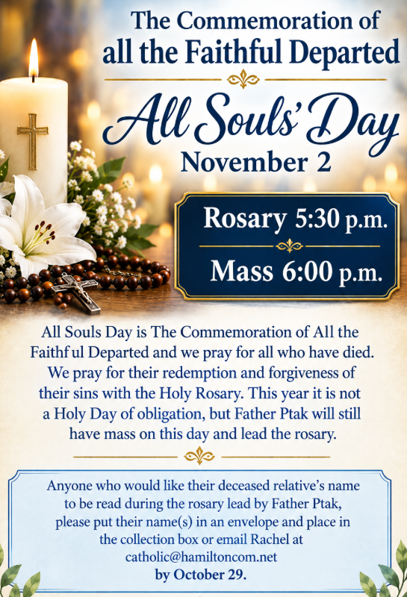
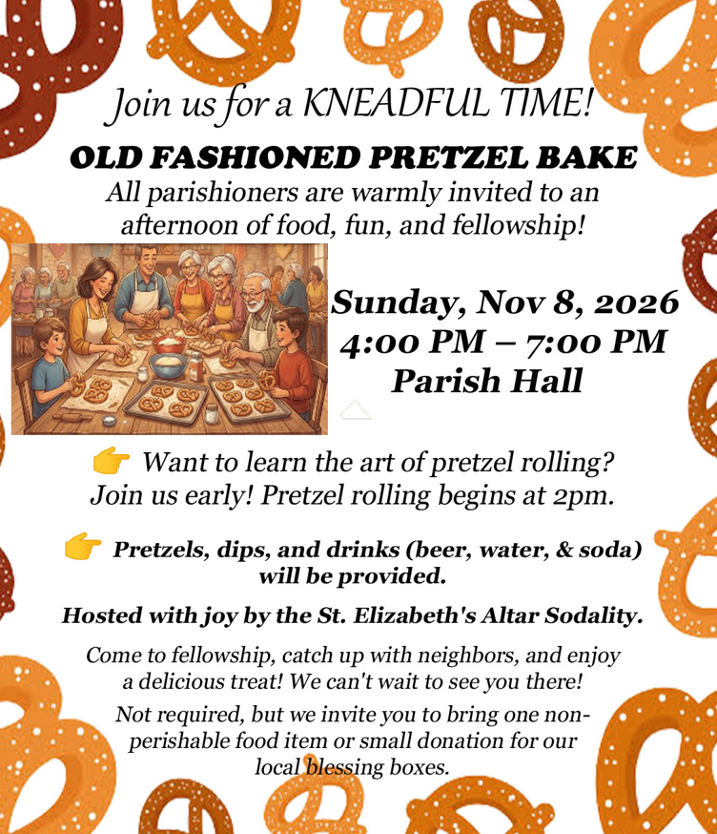

Collection ~ October 10-11
Envelopes (53) $2,652.50
Loose $ 100.00
All Saints Day (2) $ 35.00
All Souls' Day (2) $ 55.00
SJN Hall (1) $ 25.00
World Mission Sunday (2) $ 45.00
Human Development (2) $ 45.00
PSR New Hall (1) $ 50.00
One Strong (1) $ 50.00
SJB Cemetery (3) $ 170.00
SJN Cemetery (1) $ 100.00
SCR Cemetery (1) $ 100.00
SCR Cemetery In Memory of Wayne
Aydt $ 730.00
Online Giving (4) $ 182.00
Total $4,339.50
Thank You & God Bless!

Online Giving is Live!

Got to: https://osvhub.com/ stjohnbaptistil/giving/funds or scan the code.

St. John News

Shared in Common
Open House Reception to Celebrate
Betty Rapp’s 90th birthday
November 8 Dahlgren Hall 2 to 4 p.m.
All parishioners are invited. No gifts please.
If you would like to mail Betty a card her address is
909 West Whited Street, Dahlgren, IL 62828

The Holy Name Society would like to thank everyone who bought or sold raffle tickets. Raffle ticket winners:
Gun from Hamilton County Coal: Linda Keck
$150 Gift Certificate from H&R Agri-Power:
Cathy Anselment
$200 Cash from Wabash Valley: Lee Hastings
$100 Cash from Eric Rawls of Jeff Donoho
Insurance: Lowell Biggerstaff
$100 Cash from Chad Mitsdarffer County
Financial: Tim Aydt
$100 Cash from Miller Seed Solutions: Kenny
Aydt
$100 Cash from Farm Credit Lending & Crop
Insurance: Mike Karcher
$100 gift certificate from Aydt's Hardware:
Jason Kirsch
2 - 15 lb box of fish from McPeak's Fish
Market: Megan Link & Mark Hutcheson
$100 Cash from Christopher Johnson from
Pioneer Seed: Karen Karcher
2 - $100 gift card from People National Bank:
Randy Rubenacker & Dan Coy
$100 Cash from York's Country Crop
Insurance: Dave Rubenacker
$50 gift certificate from Mike's Package Liquor:
Dave Collins
$50 Wal-Mart gift card from Archie & Kristy
Bowers: Pat Harvey
$50 Lowes Gift Card from Hamilton County
Telephone Co-Op: Micky Karcher
$50 Gift Card for Wal-Mart from Fr. Slawomir
Ptak: Dan Coy

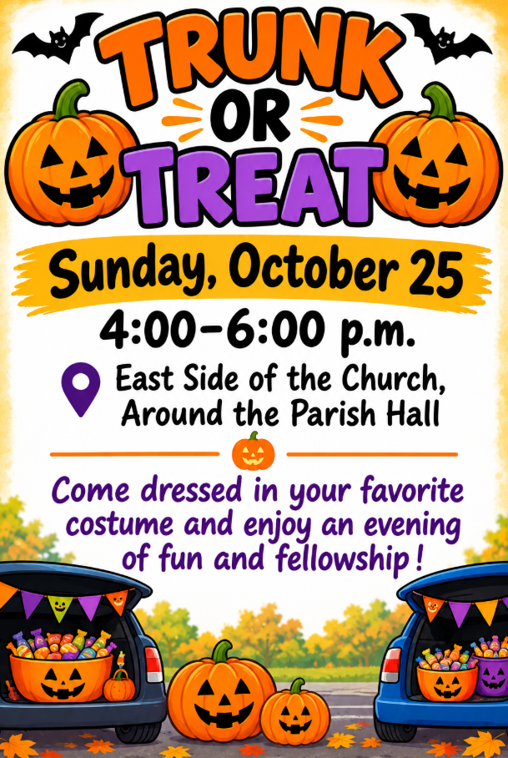
Please be set-up and ready for kids
by 3:30 p.m. If inclement weather, it will take place inside hall.
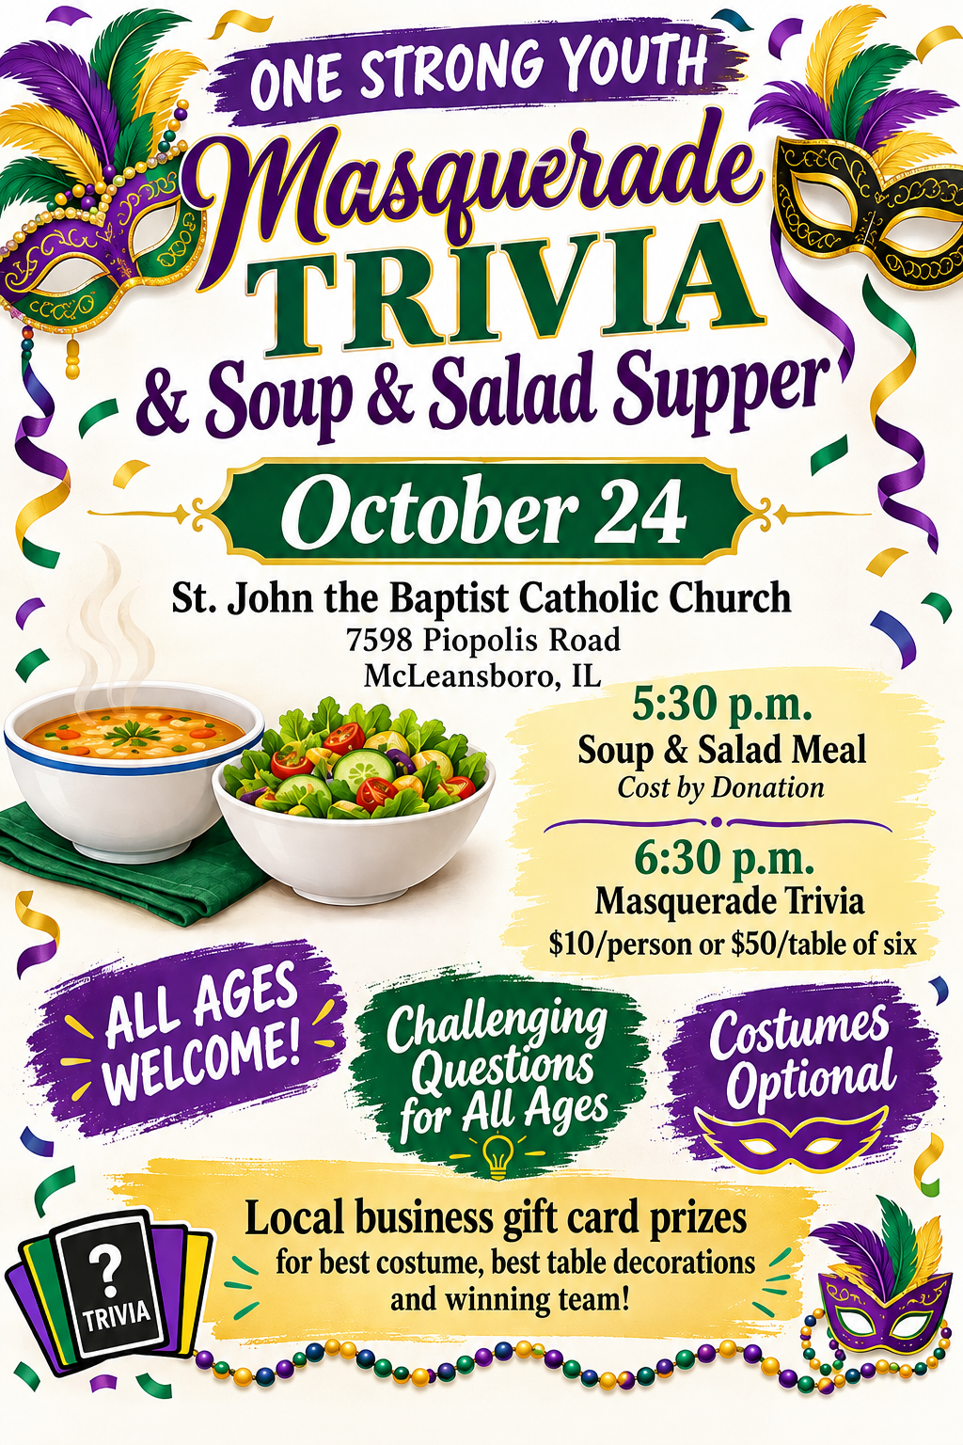
St. John News
St. Edward the Confessor and
St. John the Baptist Catholic Parishes
Twenty-Ninth Sunday in Ordinary Time ~ October 17-18, 2026
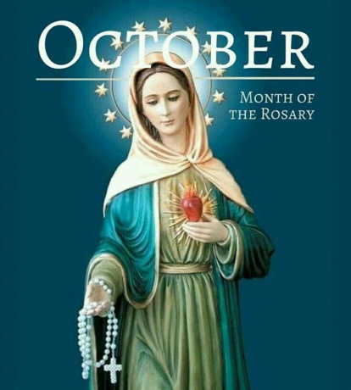
"Hail Mary full of Grace, the Lord is with You."
~ Luke 1:28 ~

Pray the Rosary Daily

Bishop of Belleville - Rev. Godfrey Mullen, OSB
Administrative Pastor - Fr. Slawomir Ptak
Phone: 618-643-3552 or email: slawekptak@yahoo.com

St. Edward the Confessor ~ Contact Information
300 NW 5th Street ~ Fairfield, IL 62837
Phone ~ 618-847-7931
E-mail ~ stedwardcatholicchurch01@frontier.com
Website ~ stedwardfairfield.com

St. John the Baptist ~ Contact Information
7598 Piopolis Road ~ McLeansboro, IL 62859
Phone ~ 618-648-2490
E-mail ~ catholic@hamiltoncom.net
Website ~ hamiltoncountycatholic.org

Office Hours October 19-23
Monday ~ Closed
Tuesday - Friday ~ 8:00 a.m. - 2:00 p.m.
Closed for Lunch ~ 12:00 p.m. - 12:30 p.m.


