Food Pantry Information

We were notified last week by the Diocese that we have received a grant for our Food Pantry. We applied for the grant through the Catholic Service and Ministry Appeal in May. We have been awarded a $1,000 grant.

Dates for upcoming Food Pantries

For 2026 : October 10, November 14, December 12
For 2027: January 9, February 13, March 13, April 10

Weekly Contribution
9/27/2026
Envelopes $1,679
Loose $ 96
Candles $ 5
Building $ 345
World Mission $ 5
Sign $ 50
Food Pantry $ 25
Attendance 83

~ Mission Statement ~
We, of St. Edward Catholic Church, Fairfield Illinois, united as a family of God's people strive to live out the Gospel of our Lord Jesus Christ through a community spirit of love and service to one another. We endeavor to touch the lives of all with God's living presence and love.
We hope to achieve these through:
- Participating in the sacraments and providing for the spiritual needs of all; the young and the elderly, those with special needs and those who are no longer very active in the parish.
- Providing a welcoming environment to all including new members who might like to join our parish and those who visit to worship with us.
- Using our gifts and talents for the life and growth of our parish and for the greater glory of God.
- Providing a comprehensive system of support services that will assist the poor and the needy as far as our scope can reach.

St. Edward News

St. Edward News

Clothesline
Thank you to our September volunteers! Teresa Williams, Linda Keck, Libby Pond and Leslie Robison.
If you are interested in volunteering, contact Leslie at 618-842-9602.

Save the Date

Saint Edward’s Veteran’s Day Breakfast is Saturday, November 7.

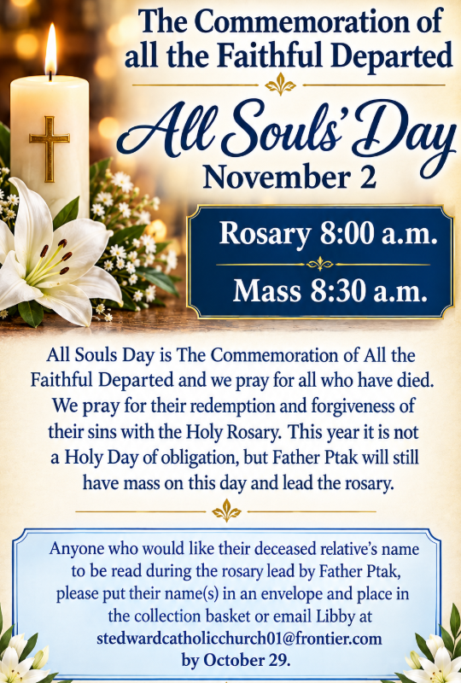
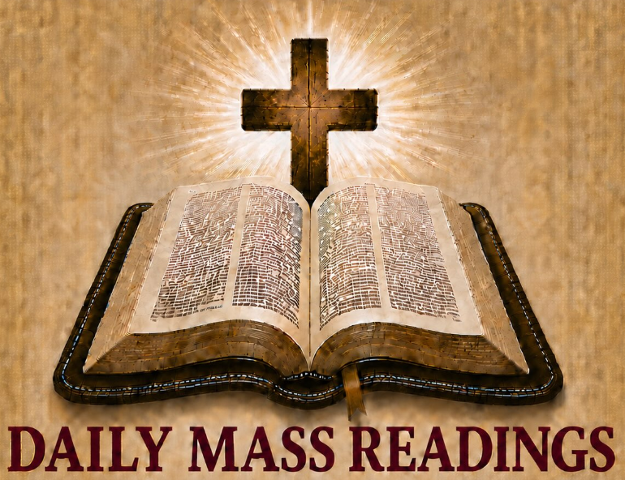

for October 4 – 10

- Sun – Is 5: 1-7 Phil 4: 6-9 Mt 21:33-43
- Mon – Ga 1: 6-12 Lk 10:25-37
- Tues – Ga 1: 13-24 Lk 10:38-42
- Wed – Ga 2:1-2, 7-14 Lk 11:1-4
- Thu – Ga 3: 1-5 Lk 11: 5-13
- Fri – Ga 3:7-14 Lk 11:15-26
- Sat – Ga 3: 22-29 Lk 11:27-28
Travel Opportunity
Pilgrimage to Poland, Prague and Medjugorie
11 day trip ~ April 19-29, 2027

It is through Journey of Faith Tours.
For more information call Carolyn at
732-216-8073 go to www.journeyoffaithtours.com/ppm27.

Or you can talk to Linda Keck,
as she is going on this pilgrimage.

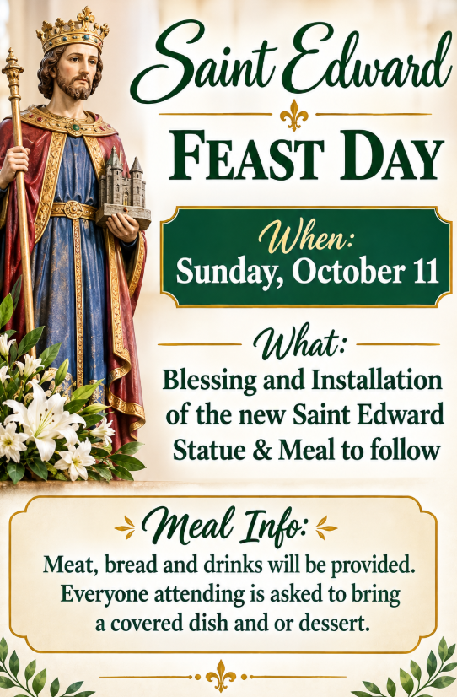
New Outdoor Electric Sign
Total Cost $24,448.66
Donations Collected $12,500.00
Needed $11,946.66
If you are interested in donating to the sign, you can place your donation in the collection. Please mark it as sign donation.

Kim Buchanan, Lanora Neavill,
Margaret & Jim Thompson,
Richard Rennier, Lee Bouldin, Father Ray, Marty Hawkins, Glory Alman,
H.G. French, Mike & Carol Oppenheimer,
Sue Milligan, Kate Krupp, Lidija Bilus, Gayla Templeman, Sharon Withrow,
Gary Snodgrass, Sandra Stence,
Paul Kalisz, Larry McDowell and
Mary Murphy

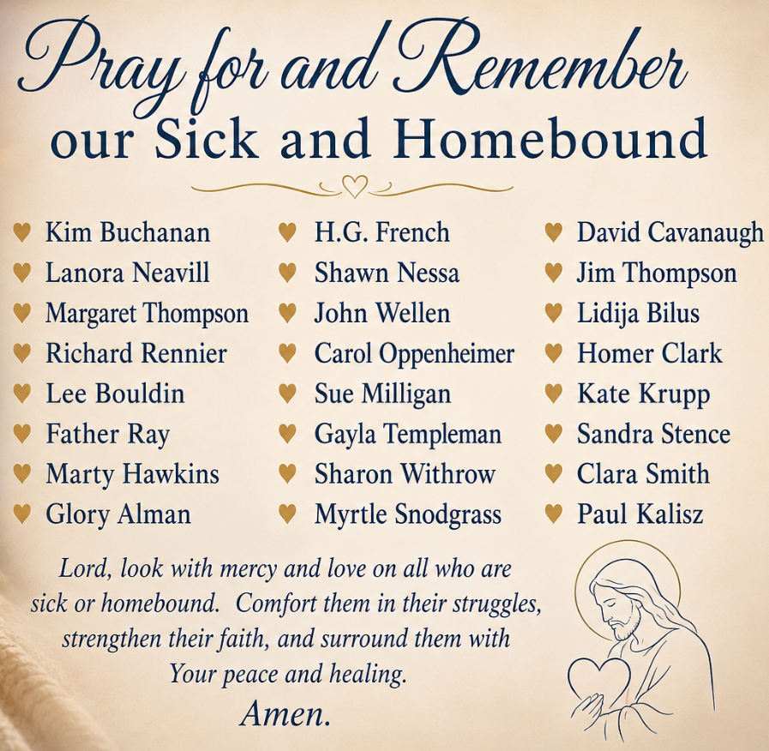

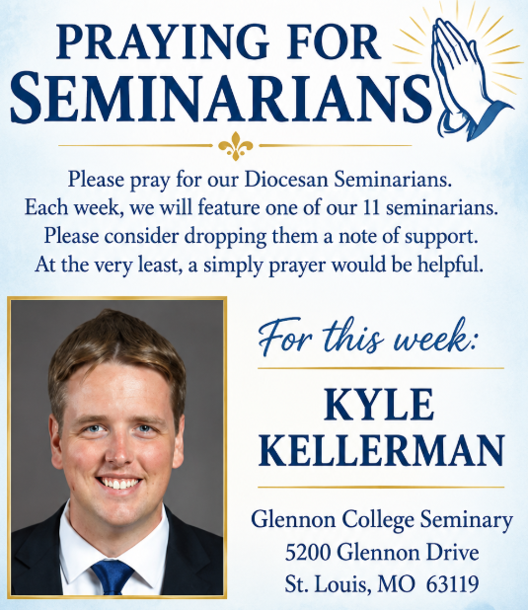

Our Parish Mission
We the parishioners of St. John the Baptist, brothers and sisters in Christ, accept as our mission: to know our faith and share it with others, to continue to grow spiritually with respect for the sacraments, to celebrate the liturgy and the Holy Eucharist as the center of our Christian life, to live by truth and love, to serve those in need, to teach by example, and thereby strengthen and inspire our Parish family in accordance with the Roman Catholic Church.

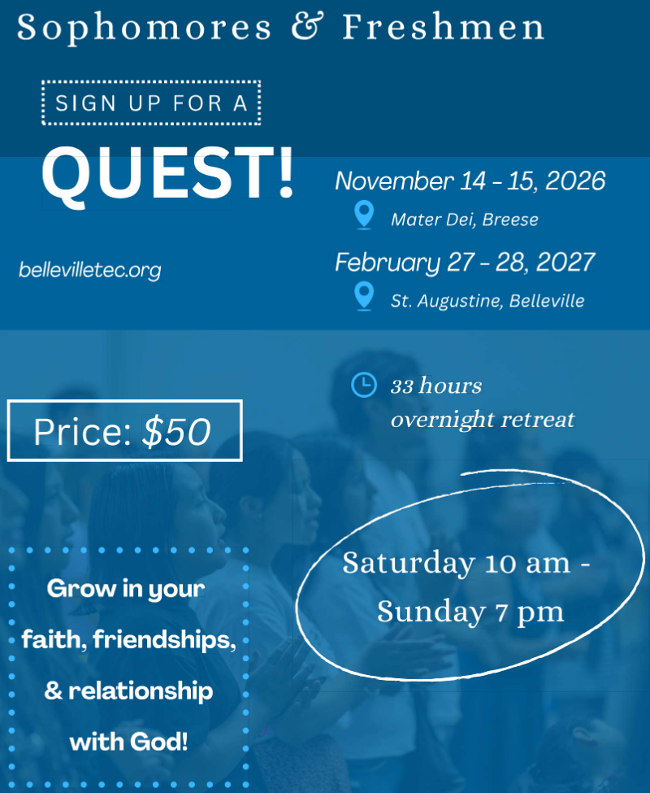
Applications can be found at www.bellevilletec.com
Shared in Common

St. John News



October
- 3: Baptism of Hudson Steele son of Levi & Kate (Billington)
- 4: PSR Sunday: HS Rosary - 5th-7th Greet - Confirmation Petitions
- 4: New Server Training after Mass
- 4: PSR & Bible Study 9:30 a.m.
- 5: Holy Name Society Meeting 6:00 p.m. Refreshments Mark Karcher
- 6: Ladies Quilting 8:00 a.m. - 1:00 p.m. City Hall/Market Street
- 6: OCIA Class 6:00 p.m.
- 8: AA/NA Meeting 7:00 p.m. City Hall/Market Street
- 11: Priest Appreciation Day
- 11: New Server Training after Mass
- 11: Holy Name Society Raffle Drawing during One Strong Breakfast after Mass
- 11: PSR Youth Safety Event 9:45 a.m. - No Bible Study
- 12-15: Diocese of Belleville Priest Convocation ~ Augustine Institute Florissant, MO
- 13-15: No Weekday Masses
- 13: Ladies Quilting 8:00 a.m. - 1:00 p.m. City Hall/Market Street
- 15: KC #8745 Meeting at Dahlgren 7:00 p.m.
- 15: KC #7118 Meeting at Enfield 7:00 p.m.
- 15: AA/NA Meeting 7:00 p.m. City Hall/Market Street
- 17: Mass with Bishop Godfrey 9:00 a.m. followed with Diocese Pastoral Plan Meeting
- 18: New Server Training after Mass
- 18: PSR & Bible Study 9:30 a.m.
- 18: One Strong Youth Feeding the Foxes followed with Youth Group
- 20: Ladies Quilting 8:00 a.m. - 1:00 p.m. City Hall/Market Street
- 20: OCIA Class 6:00 p.m.
- 22: AA/NA Meeting 7:00 p.m. City Hall/Market Street
- 24: One Strong Youth Masquerade Trivia & Soup & Salad Supper 6:00 - 9:00 p.m.

For This Week

CLINTON RAUCH
Saint Meinrad Seminary
200 Hill Drive
St. Meinrad, IN 47577

Saint John Vianney, pray for us.


"I am the voice of one calling in the desert, Make straight the way of the Lord."
Jn 1:23
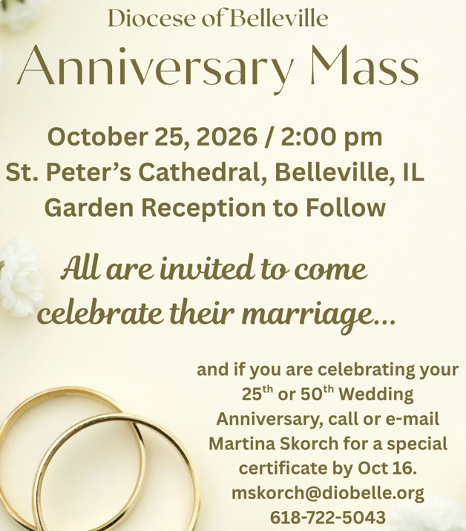

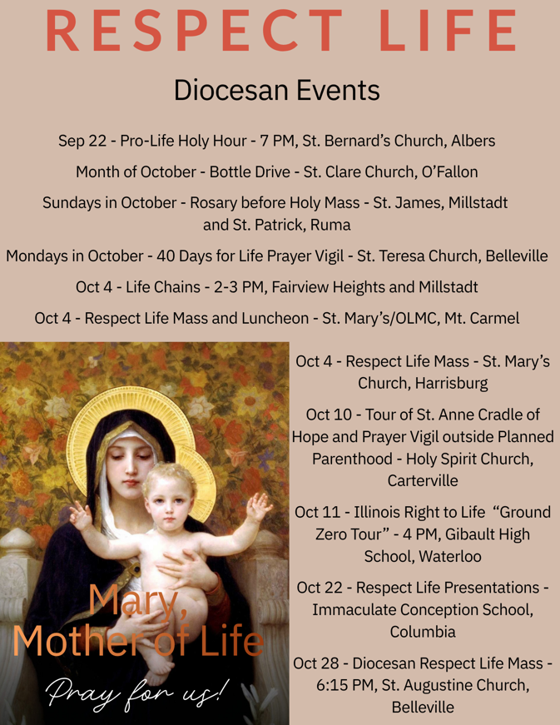
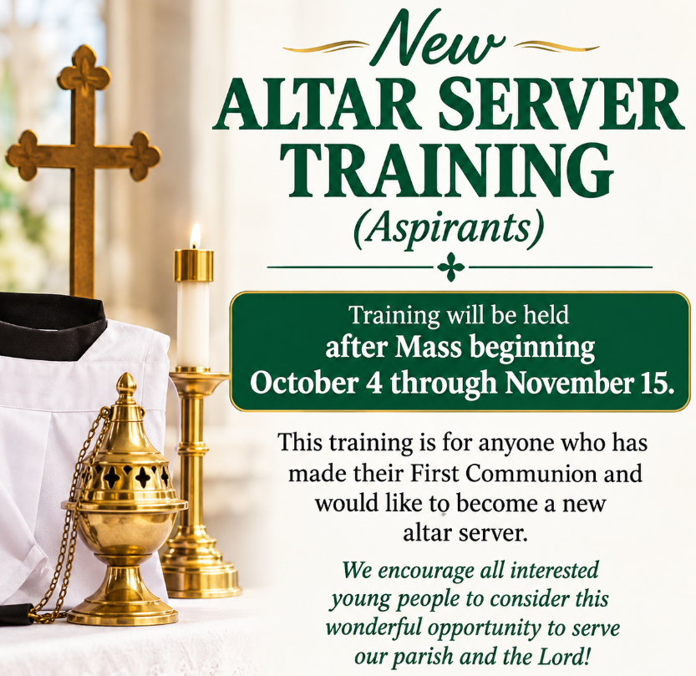
St. Elizabeth's Altar Sodality received $1,ooo from the CSMA Grant. This money will be used for their yearly Advent bags for the homebound and elderly.

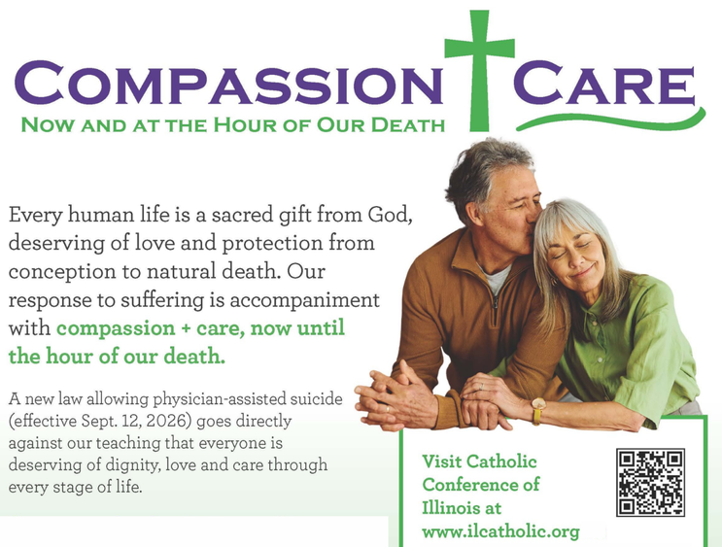
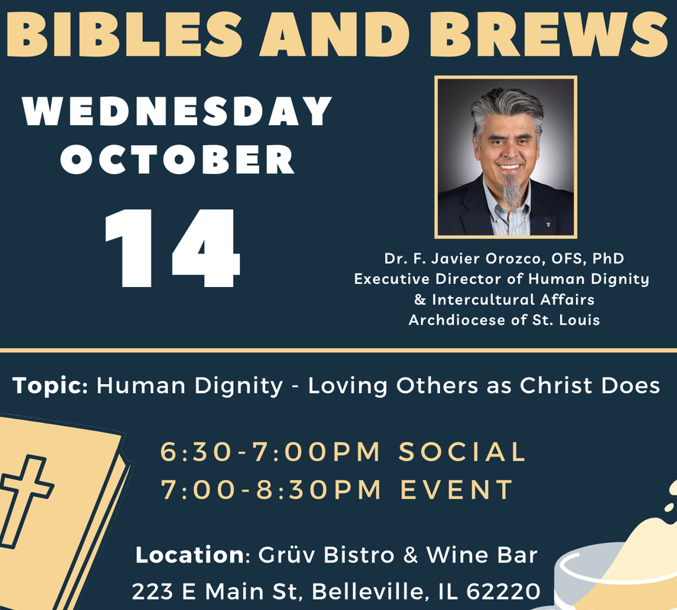
October Liturgical Calendar
- 4: World Communion & Respect Life
Sunday
- 5: St. Faustina Kowalska, Virgin &
Blessed Francis Xavier Seelos, Priest
- 6: St. Bruno, Priest & Blessed Marie
Rose Durocher, Virgin
- 7: Our Lady of the Rosary
- 9: St. Denis, Bishop and Companions,
Martyrs & St. John Leonardi, Priest

Mass Intentions for the Twenty-Seventh Week in Ordinary Time
Tues. Oct. 6 St. Edward 6:00 p.m. †Larry Meisner, †Donna Turner, For the gift of strength for those suffering from chronic illnesses
Wed. Oct. 7 St. John 6:00 p.m. †Clem Aydt, †Gordon Coy, †Ryan Rubenacker
Thur. Oct. 8 St. Edward 8:00 a.m. All Parish Family
Fri. Oct. 9 St. John 8:00 a.m. †Joe Haas, ††Jack & Frances Allen, †Rosanna Nice

Mass Intentions for Twenty-Eighth Sunday in Ordinary Time
Sat. Oct. 10 St. John 5:00 p.m. ††Gilbert, Edward, & Joe Jr. Rapp, †Christine Reyling, †Betty Ann Anselment
Sun. Oct. 11 St. John 8:30 a.m. All Parish Family
Sun. Oct. 11 St. Edward 10:30 a.m. †John Robison Jr., †John Robison III, †Denise Francis Smith

Sacrament of Reconciliation before weekend masses.

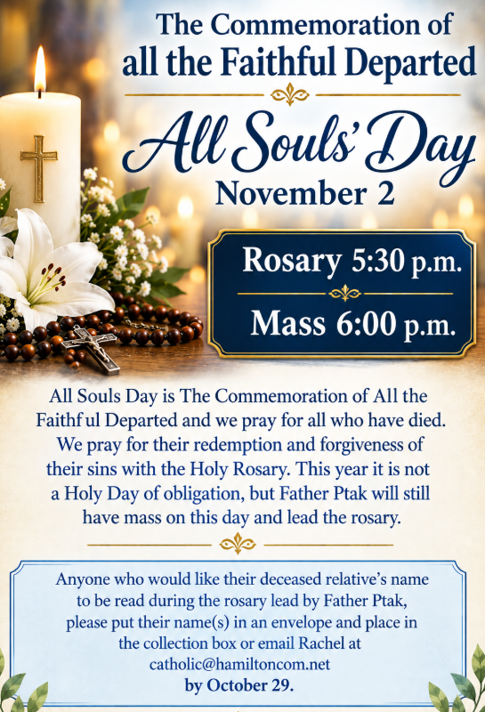
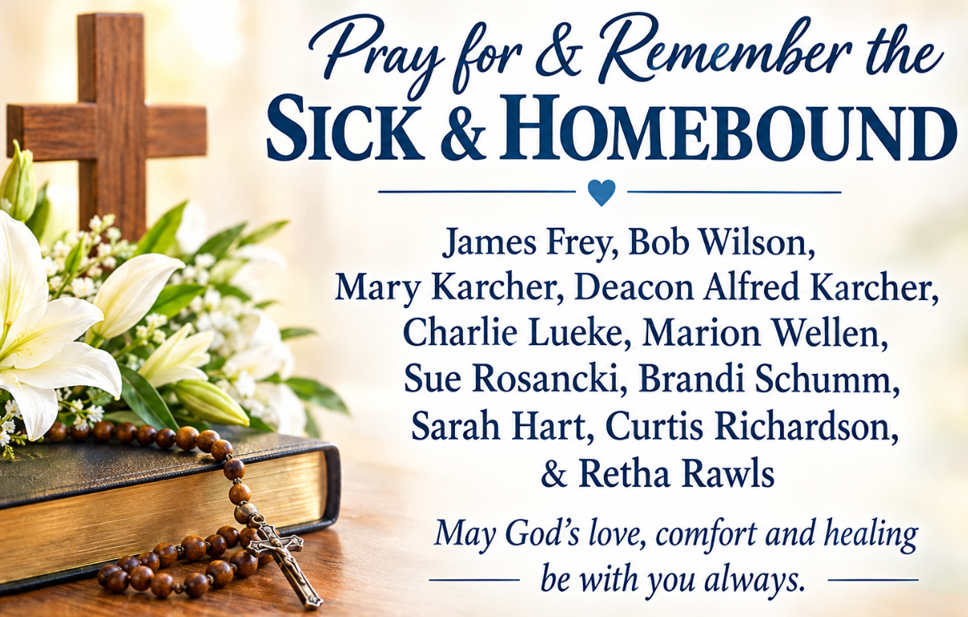
St. John News
Collection ~ September 26-27
General In Memory of Rosanna
Nice $ 100.00
Envelopes (44) $1,741.00
Loose $ 64.00
All Saints Day (1) $ 50.00
All Souls Day (1) $ 50.00
Assumption (1) $ 10.00
Retired Diocese Priest (1) $ 10.00
SJB Building (4) $ 260.00
SJN Building (1) $ 35.00
One Strong Youth (1) $ 10.00
SJB Cemetery (2) $ 75.00
SJN Cemetery (1) $ 250.00
Online Giving (3) $ 80.00
Total $2,735.00

Thank You & God Bless!

Online Giving is Live!

Got to: https://osvhub.com/ stjohnbaptistil/giving/funds or scan the code.

Shared in Common
"Hail Mary full of Grace,
the Lord is with You."
~ Luke 1:28 ~

Pray the Rosary Daily
A Note of Thanks
The family of Rosanna Nice would like to extend a note gratitude and thanks to the Saint Elizabeth Alter Society ladies who helped host the luncheon after our mother's funeral. Your kindness will not be forgotten. The family would also like to thank Fr Ptak, Rachel in the parish office and Teresa Wellen for their assistance in making our Moms funeral mass very special. The music provided by Debbie Wellen was exceptional. Thank you all.
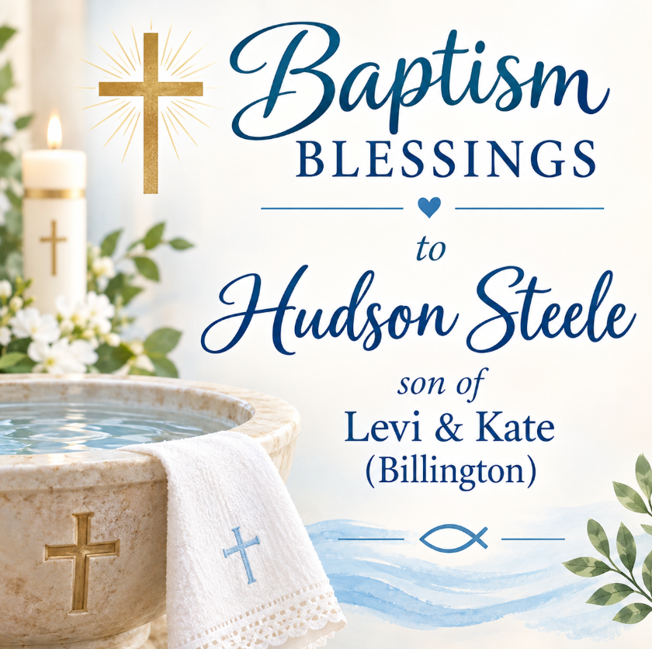

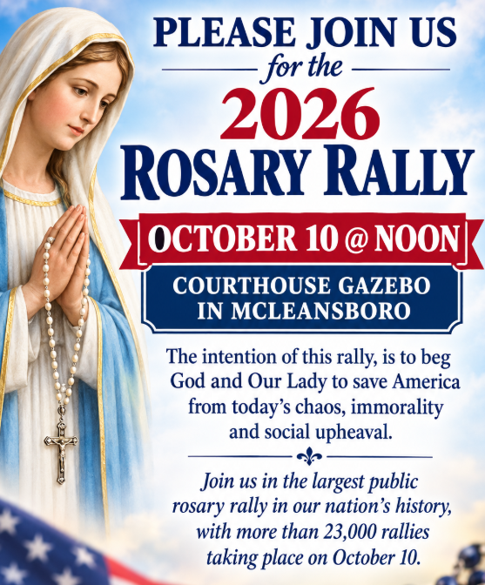
New Parish Hall Information & Construction Update
Total Project Cost $2,500,000
Cash Available ($1,731,137)
Current Pledges ($ 691,669)
Pledges/Donations Needed $ 77,194

The roof and exterior walls except for north side is complete. Insulation on the exterior walls is in progress and some interior walls has been delivered. We are grateful for the continued progress on our new parish hall and for everyone who has supported this project. Please continue to pray for all those working on the construction and for their safety as they labor to bring this project to completion.
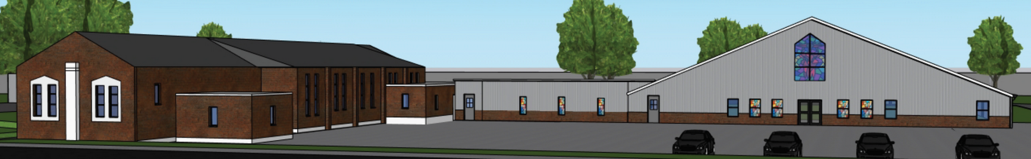
St. John News
St. Edward the Confessor and
St. John the Baptist Catholic Parishes
Twenty-Seventh Sunday in Ordinary Time ~ October 3-4, 2026

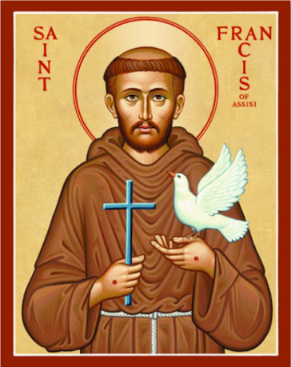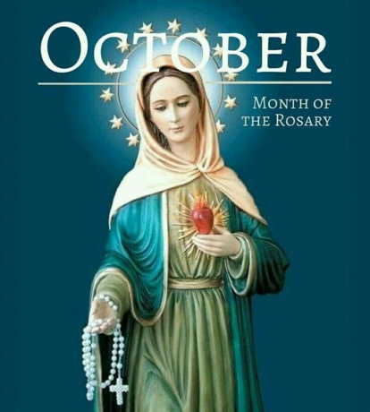

"Give us the courage to build bridges where the world raises up boundaries. In this time afflicted by conflict and division, intercede for us so that we may become peacemakers."
~ Pope Leo ~

St. Edward the Confessor ~ Contact Information
300 NW 5th Street ~ Fairfield, IL 62837
Phone ~ 618-847-7931
E-mail ~ stedwardcatholicchurch01@frontier.com
Website ~ stedwardfairfield.com

St. John the Baptist ~ Contact Information
7598 Piopolis Road ~ McLeansboro, IL 62859
Phone ~ 618-648-2490
E-mail ~ catholic@hamiltoncom.net
Website ~ hamiltoncountycatholic.org

Office Hours October 5-9
Monday, Thursday, & Friday ~ Closed
Tuesday & Wednesday ~ 8:00 a.m. - 2:00 p.m.
Closed for Lunch ~ 12:00 p.m. - 12:30 p.m.


