Food Pantry Information

We were notified last week by the Diocese that we have received a grant for our Food Pantry. We applied for the grant through the Catholic Service and Ministry Appeal in May. We have been awarded a $1,000 grant.

Dates for upcoming Food Pantries

For 2026 : October 10, November 14, December 12
For 2027: January 9, February 13, March 13, April 10

Weekly Contribution
9/27/2026
Envelopes $1,679
Loose $ 96
Candles $ 5
Building $ 345
World Mission $ 5
Sign $ 50
Food Pantry $ 25
Attendance 83

~ Mission Statement ~
We, of St. Edward Catholic Church, Fairfield Illinois, united as a family of God's people strive to live out the Gospel of our Lord Jesus Christ through a community spirit of love and service to one another. We endeavor to touch the lives of all with God's living presence and love.
We hope to achieve these through:
- Participating in the sacraments and providing for the spiritual needs of all; the young and the elderly, those with special needs and those who are no longer very active in the parish.
- Providing a welcoming environment to all including new members who might like to join our parish and those who visit to worship with us.
- Using our gifts and talents for the life and growth of our parish and for the greater glory of God.
- Providing a comprehensive system of support services that will assist the poor and the needy as far as our scope can reach.

St. Edward News

St. Edward News

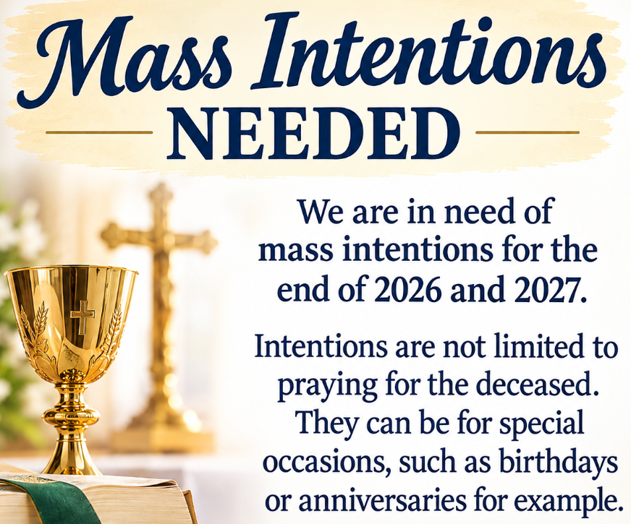
Compassion Pregnancy Walk-a-thon

Teresa Williams will be participating in the walk-a-thon. If you would like to help her raise money for the worthy cause, the signup sheet is on the table in the hall.

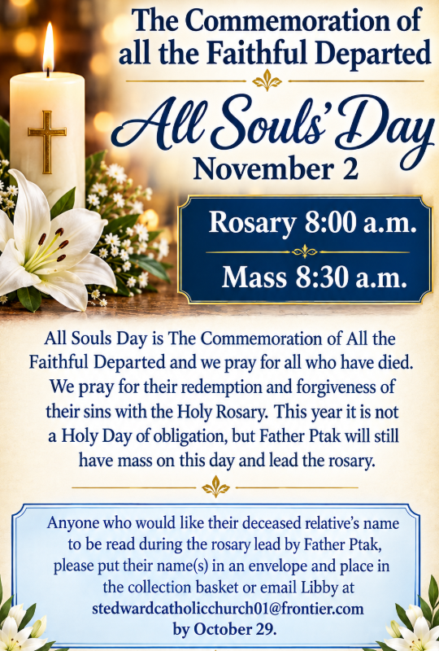
Congratulations St. Edward

We have reached our CSMA goal of $6,948.

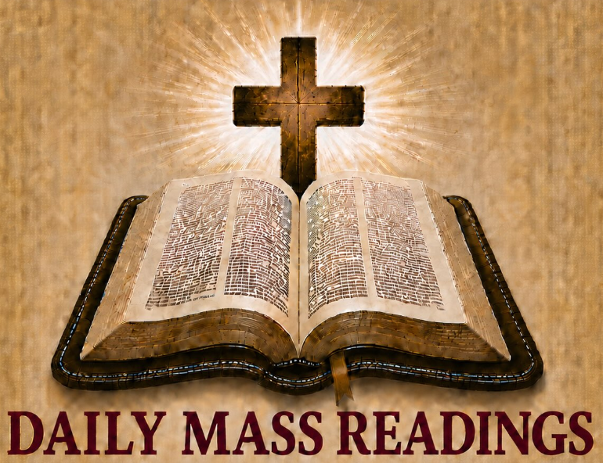

for October 11-17

- Sun – Is 25:6-10a Phil 4:12-14, 19-20
Mt 22:1-14
- Mon – Ga 4:22-24, 26-27, 31-5:1
Lk 11:29-32
- Tues – Ga 5:1-6 Lk 11:37-41
- Wed – Ga 5:18-25 Lk 11:42-46
- Thu – Eph 1:1-10 Lk 11: 47-54
- Fri – Eph 1:11-14 Lk 12:1-7
- Sat – Eph 1:15-23 Lk 12:8-12

Travel Opportunity
Pilgrimage to Poland, Prague and Medjugorie
11 day trip ~ April 19-29, 2027

It is through Journey of Faith Tours.
For more information call Carolyn at
732-216-8073 go to www.journeyoffaithtours.com/ppm27.

Or you can talk to Linda Keck,
as she is going on this pilgrimage.

New Outdoor Electric Sign
Total Cost $24,448.66
Donations Collected $12,500.00
Needed $11,946.66
If you are interested in donating to the sign, you can place your donation in the collection. Please mark it as sign donation.

Kim Buchanan, Lanora Neavill,
Margaret & Jim Thompson,
Richard Rennier, Lee Bouldin, Father Ray, Marty Hawkins, Glory Alman,
H.G. French, Mike & Carol Oppenheimer,
Sue Milligan, Kate Krupp, Lidija Bilus, Gayla Templeman, Sharon Withrow,
Gary Snodgrass, Sandra Stence,
Paul Kalisz, Larry McDowell and
Mary Murphy

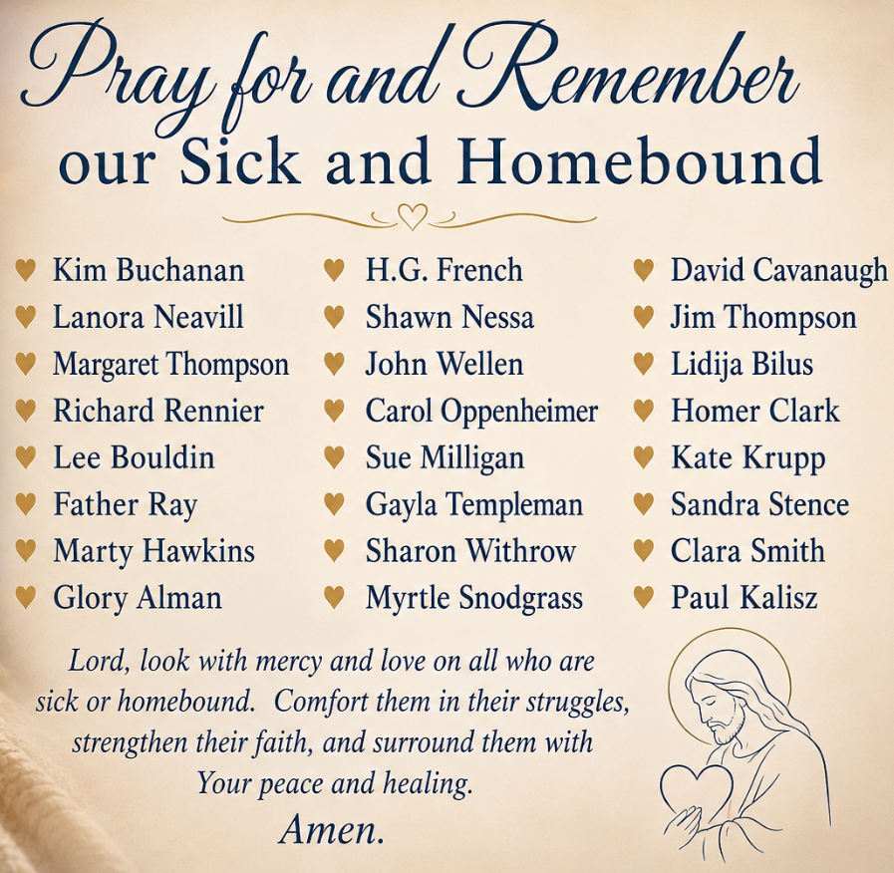

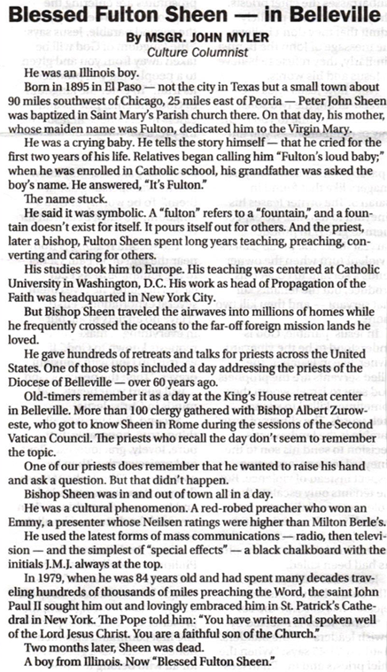
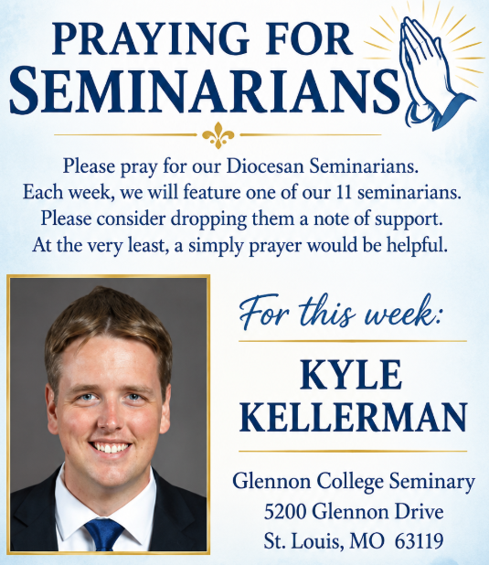

Our Parish Mission
We the parishioners of St. John the Baptist, brothers and sisters in Christ, accept as our mission: to know our faith and share it with others, to continue to grow spiritually with respect for the sacraments, to celebrate the liturgy and the Holy Eucharist as the center of our Christian life, to live by truth and love, to serve those in need, to teach by example, and thereby strengthen and inspire our Parish family in accordance with the Roman Catholic Church.

Shared in Common

St. John News



October
- 11: Priest Appreciation Day
- 11: New Server Training after Mass
- 11: Holy Name Society Raffle Drawing during One Strong Breakfast after Mass
- 11: PSR Youth Safety Event 9:45 a.m. - No Bible Study
- 12-15: Diocese of Belleville Priest Convocation ~ Augustine Institute Florissant, MO
- 13-15: No Weekday Masses
- 13: Ladies Quilting 8:00 a.m. - 1:00 p.m. City Hall/Market Street
- 15: KC #8745 Meeting at Dahlgren 7:00 p.m.
- 15: KC #7118 Meeting at Enfield 7:00 p.m.
- 15: AA/NA Meeting 7:00 p.m. City Hall/Market Street
- 17: Mass with Bishop Godfrey 9:00 a.m. followed with Diocese Pastoral Plan Meeting
- 18: New Server Training after Mass
- 18: PSR & Bible Study 9:30 a.m.
- 18: One Strong Youth Feeding the Foxes followed with Youth Group
- 20: Ladies Quilting 8:00 a.m. - 1:00 p.m. City Hall/Market Street
- 20: OCIA Class 6:00 p.m.
- 22: AA/NA Meeting 7:00 p.m. City Hall/Market Street
- 24: One Strong Youth Soup & Salad Supper 5:30 p.m. Masquerade Trivia 6:30 p.m.
- 25: New Server Training after Mass
- 25: PSR & Bible Study 9:30 a.m.
- 25: October 25 Trunk or Treat 4:00-6:00 p.m. on the east side or church around hall.
- 27: Ladies Quilting 8:00 a.m. - 1:00 p.m. City Hall/Market Street
- 28: East Vicariate Priest Gathering 11:00 a.m. - St. Mary Mt. Carmel
- 29: AA/NA Meeting 7:00 p.m. City Hall/Market Street
- 31: All Souls' Day St. John the Baptist Cemetery Visit to pray and place lit candles after Mass.

For This Week

CHRIS BERRY
Saint Meinrad Seminary
200 Hill Drive
St. Meinrad, IN 47577

Saint John Vianney, pray for us.


"I am the voice of one calling in the desert, Make straight the way of the Lord."
Jn 1:23
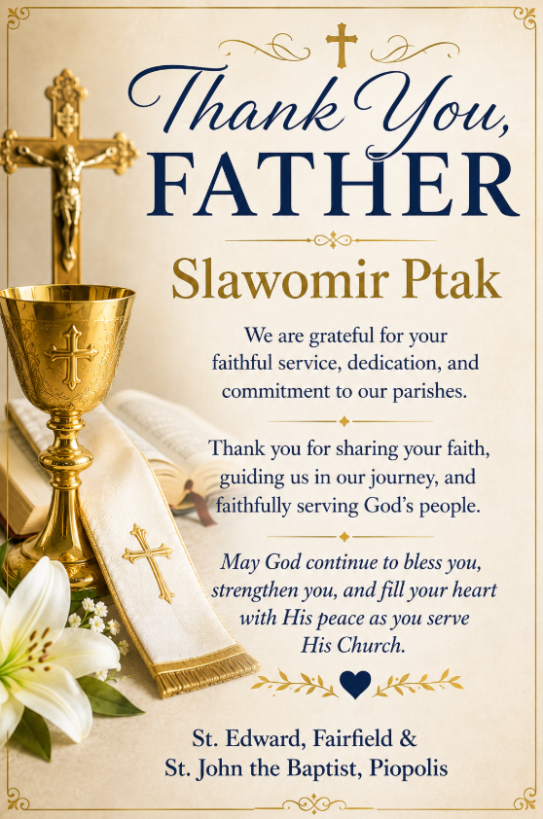

Annual Diocesan Spring
Farm Blessing
October 23 ~ 1:00 p.m.
Mike & Julie Dietz Farm
9920 Reider Road
Lebanon, IL
October Liturgical Calendar
- 11: Priest Appreciation Day
- 14: St. Callistus I, Pope & Martyr
- 15: St. Teresa of Jesus, Virgin &
Doctor
- 16: St. Hedwig, Religious & St.
Margaret Mary Alacoque, Virgin
- 17: St. Ignatius of Antioch, Bishop and
Martyr
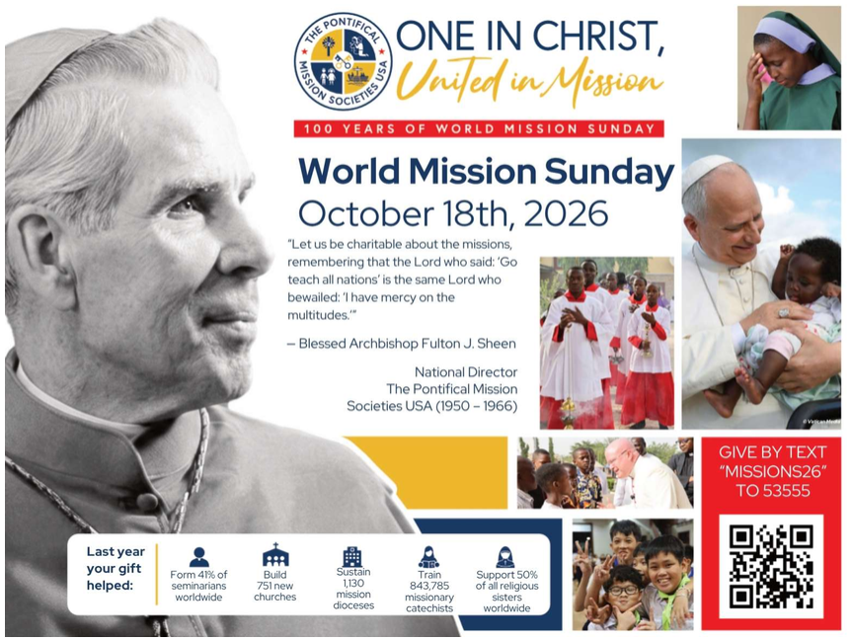
For more information read the attach letter from Bishop Godfrey or go to https://www.diobelle.org/main-rotator/2726 or https://pontificalmissions.org/wms-2026. Collection envelope for World Mission Sunday located in your envelope packet.
Mass Intentions for the Twenty-Eighth Week in Ordinary Time
October 12-15 ~ Diocese Priest Convocation Augustine Institute Florissant, MO
Fri. Oct. 16 St. John 8:00 a.m. ††Floyd & Norma Collins, †Sonny Anselment, ††Larry Rawls & Lucy Manning
Sat. Oct. 17 St. John 9:00 a.m. Mass with Bishop Godfrey (Part of Diocese Pastoral Plan Meeting) - Everyone can attend Mass

Mass Intentions for Twenty-Ninth Sunday in Ordinary Time
Sat. Oct. 17 St. John 5:00 p.m. All Parish Family
Sun. Oct. 18 St. John 8:30 a.m. ††SV & Clara Hopfinger, ††Theodore & Lena Reyling, ††Francis & Eileen Hopfinger
Sun. Oct. 18 St. Edward 10:30 a.m. †Larry Mouzin, †Terry Lawler, Living and Deceased Members of the Frank Family

Sacrament of Reconciliation before weekend masses.

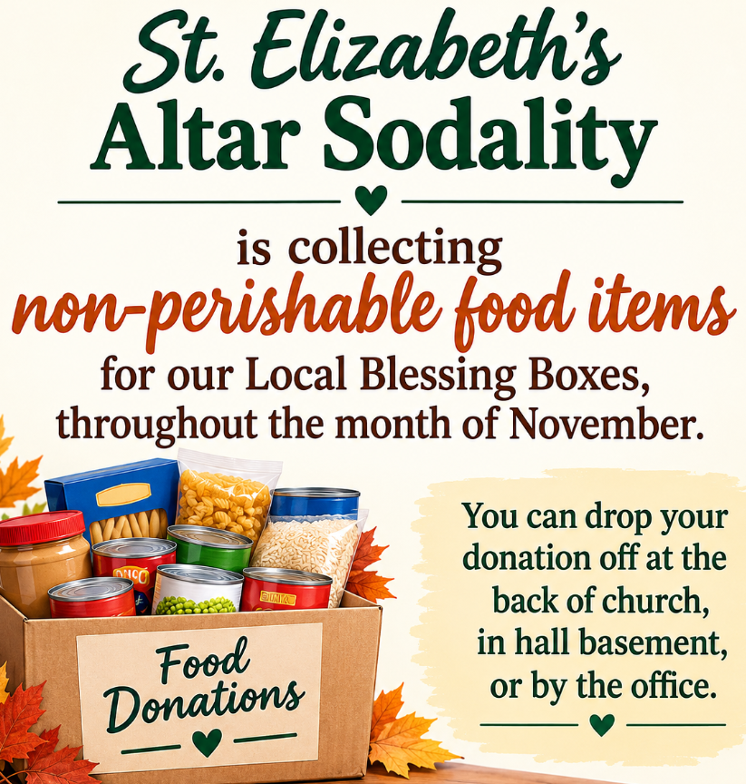
Collection ~ October 3-4
Envelopes (38) $3,262.00
Loose $ 126.00
Needy in Parish (1) $ 200.00
Retired Diocese Priest (1) $ 300.00
SJB Cemetery (17) $ 685.00
SJN Cemetery (1) $ 40.00
Online Giving (6) $ 322.00
Total $4,935.00

Thank You & God Bless!

Online Giving is Live!

Got to: https://osvhub.com/ stjohnbaptistil/giving/funds or scan the code.


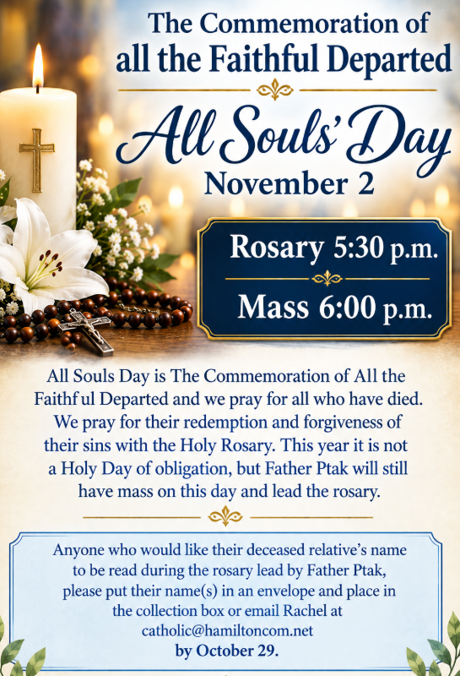
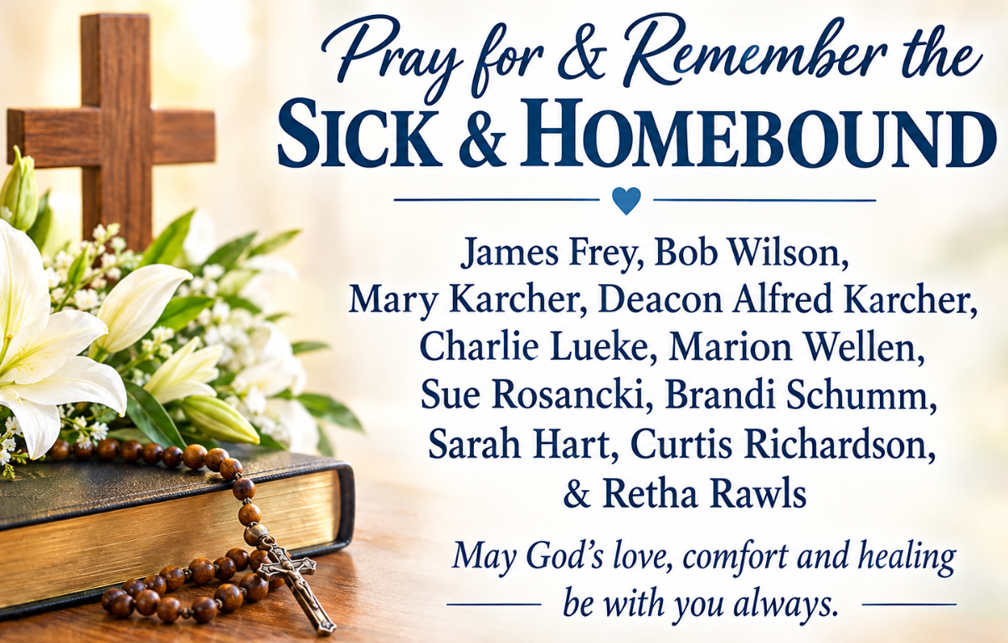
St. John News

Shared in Common
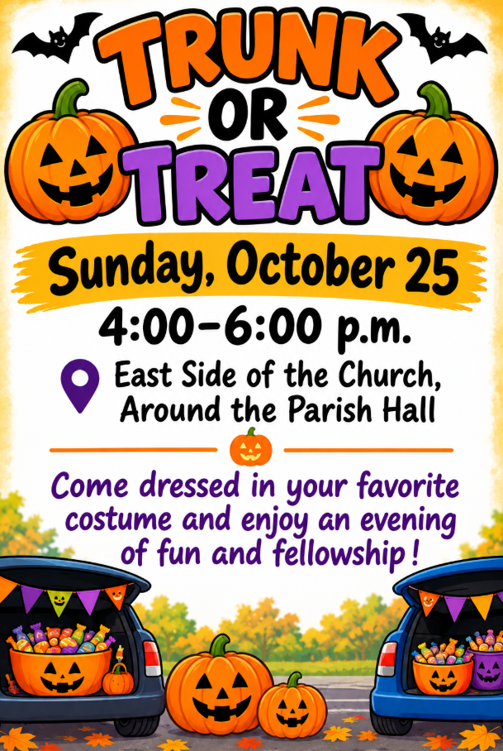
Please be set-up and ready for kids
by 3:30 p.m. If inclement weather, it will take place inside hall.
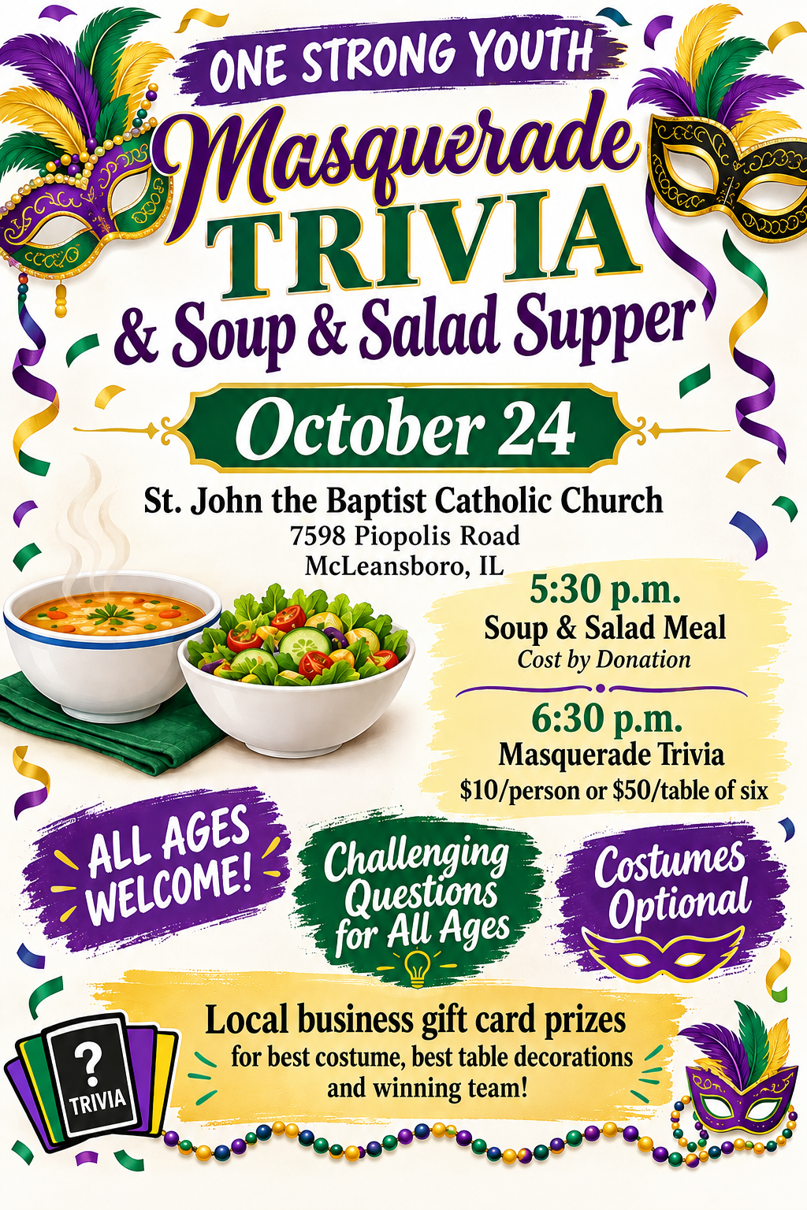
Catholic Service Ministry Appeal
Goal ~ $9,866 / Collected or Pledge-to-Date ~ $4,837.50
“Positive interactions with our brothers and sisters in need honor God, reflect love and foster a cycle of goodness which is so desperately needed in our world today. Join us in our mission to serve those in need here in our Belleville Diocese. Please consider making a gift to CSMA. Thank you for your consideration and support.” ~ Most Rev. Godfrey Mullen, OSB

New Parish Hall Information & Construction Update
Total Project Cost $2,500,000
Cash Available ($1,731,137)
Current Pledges ($ 691,669)
Pledges/Donations Needed $ 77,194

Thank you all for your donations so far to the new building. Your financial support has been amazing! Because of your generosity, we haven’t had to take the loan from the Diocese yet. We will, but we’ve been able to delay it, thus saving interest! As we near the end of the year, don’t forget to fulfill your pledge contributions for 2026. And for those who didn’t pledge, you can still make any donation any time. Pledge cards are located at each door of church and can be placed in collection marked New Hall.
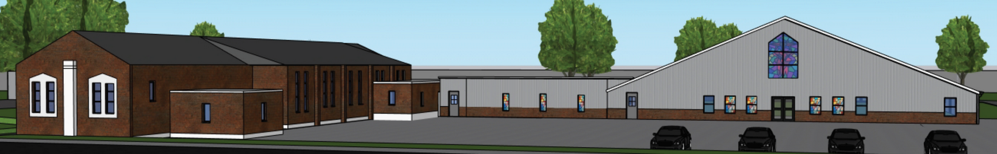
St. John News
St. Edward the Confessor and
St. John the Baptist Catholic Parishes
Twenty-Eighth Sunday in Ordinary Time ~ October 10-11, 2026
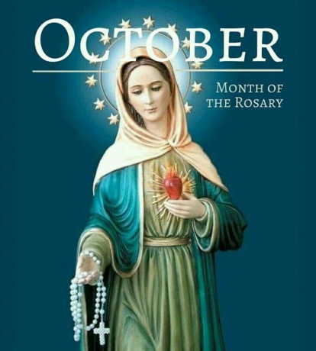
"Hail Mary full of Grace, the Lord is with You."
~ Luke 1:28 ~

Pray the Rosary Daily

Bishop of Belleville - Rev. Godfrey Mullen, OSB
Administrative Pastor - Fr. Slawomir Ptak
Phone: 618-643-3552 or email: slawekptak@yahoo.com

St. Edward the Confessor ~ Contact Information
300 NW 5th Street ~ Fairfield, IL 62837
Phone ~ 618-847-7931
E-mail ~ stedwardcatholicchurch01@frontier.com
Website ~ stedwardfairfield.com

St. John the Baptist ~ Contact Information
7598 Piopolis Road ~ McLeansboro, IL 62859
Phone ~ 618-648-2490
E-mail ~ catholic@hamiltoncom.net
Website ~ hamiltoncountycatholic.org

Office Hours October 12-16
Monday ~ Closed
Tuesday - Friday ~ 8:00 a.m. - 2:00 p.m.
Closed for Lunch ~ 12:00 p.m. - 12:30 p.m.


